OFFICIAL COORDINATION REQUEST FOR
NON-ROUTINE OPERATIONS AND MAINTENANCE

COORDINATION DATE- 13 July 2010
PROJECT- Bonneville Lock and Dam – Washington Shore Fish Ladder
RESPONSE DATE- 30 July 2010

Description of the problem- The Corps of Engineers is designing a prototype adult Pacific lamprey passage structure designed to improve lamprey passage at the Bonneville WA Shore north downstream entrance (NDE). Construction is scheduled to be completed during the 2010-2011 in-water-work (IWW) period. The structure consists of a system of steel flumes, water supply pipes, two pumps, pump screens and cleaners, and support structures (Figure 1 below). Most of the system will be placed along the tailrace side of the south wall, between NDE and the north upstream entrance (NUE). Construction of this structure requires work outside the normal 2010-2011 IWW period of 1 December through 28 February. Actual installation of the lamprey flumes and water supply system is not scheduled to begin until 1 December, but an additional two weeks of ladder outage is needed to prepare for installation. In order to complete installation of the prototype lamprey passage structure, we are requesting an extension of the IWW period to 15 November through 28 February. The Corps is aware of the need to minimize an outage of this ladder during the spring, when salmon and Pacific lamprey are vulnerable to predation by sea lions. The requested November start date is intended to avoid a March outage of the ladder.

Type of outage required- Ladder outage outside normal IWW period.

Impact on facility operation- Impact to the fish run will need to be assessed.

Length of time for repairs- 15 November 2010 to 28 February 2011

Expected impacts on fish passage- There will likely be little impact to ESA-listed adult and juvenile salmonids during the proposed extension period and little to no impact on Pacific lamprey. Steelhead migration is the most important activity during the proposed outage extension of mid to late-November, with Chinook and coho passage declining to minimal levels by the end of the month.

From 15 November to 1 December:
In 2009, 125 Chinook salmon passed BON, with counts descending to fewer than 4 fish per day by 25 November. In total, 597 steelhead passed BON in 2009, averaging 35 fish per day during this period. In some years, steelhead passage from mid-November through 1 December can be substantial. In 2007, 2444 steelhead were counted at BON during this period. In 2009, 325 coho passed the dam, with counts dropping to fewer than 10 fish per day by November 25. Chum salmon pass BON in low numbers in November. Pacific lamprey passage is typically minimal this late in the year, ranging from -4 to 4 since 2005.

From 1 December through February 28:
There is very little salmon passage activity at Bonneville dam during the winter, but this outage would overlap with the winter steelhead passage season. In 2009, 2334 passed BON during this period.

Comments from agencies.
CRITFC (Heinith)- -----Original Message-----
From: Bob Heinith
Sent: Thursday, July 15, 2010 2:40 PM
Subject: Re: FPOM/FFDRWG: Official Coordination BON WS extended outage

CRITFC supports extending the in-water work period into November as necessary to complete the lamprey entrance structure at Bonneville Dam Washington Shore Fishway. The dire status of lamprey based upon dismal 2009-2010 adult counts at Bonneville, and the priority for lamprey to use the Washington Shore Fishway and the current poor passage performance at this ladder indicated by lamprey tagging studies calls for expedited passage improvements. Thanks for the opportunity to comment.- Bob

NOAA (Fredricks) – -----Original Message-----
From: Gary Fredricks [mailto:Gary.Fredricks@noaa.gov]
Sent: Thursday, July 15, 2010 2:47 PM
Subject: Re: FPOM/FFDRWG: Official Coordination BON WS extended outage

We are ok with the two week in-water work extension into November. Thanks, Gary

Final results- USACE will go forward with scheduling the early outage of the WS fishway for the lamprey work.

Please email or call with questions or concerns.
Sean Tackley
503-808-4751
sean.c.tackley@usace.army.mil

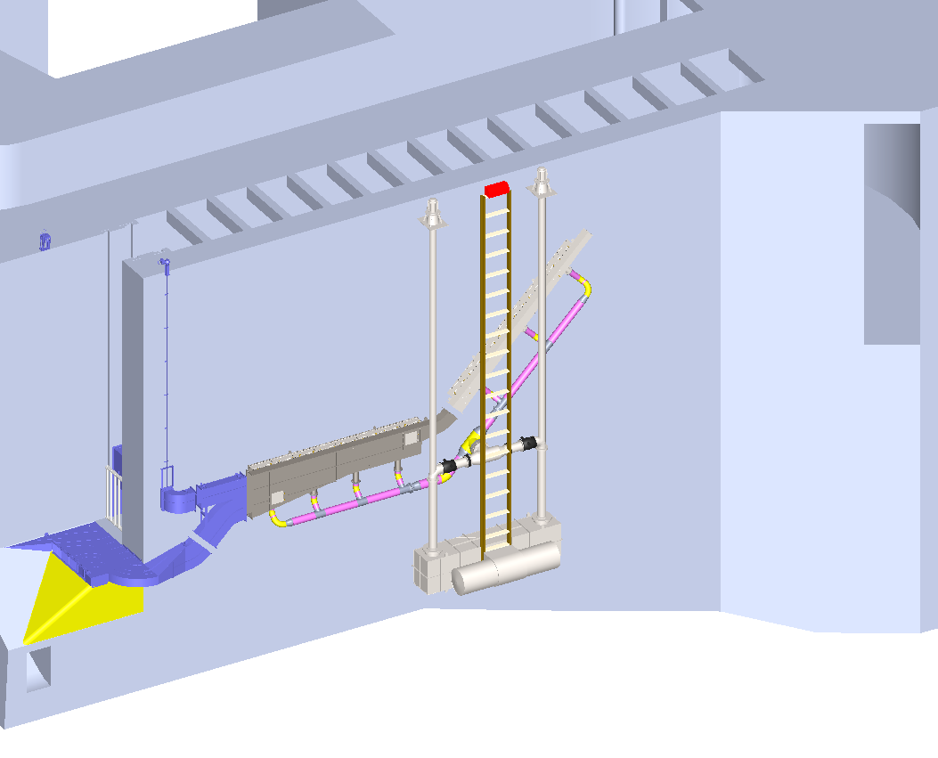

Figure 1. 3-dimensional rendering of proposed prototype lamprey passage structure and pump system.

